

**SIGNING-UP FOR PARTICIPATION IN THE CPTD MANAGEMENT SYSTEM AND UTILISING THE CPTD SELF SERVICE PORTAL MAXIMALLY**

**INTRODUCTION**

SACE is phasing-in the implementation of the CPTD Management System with the support of the Department of Basic Education, 9 Provincial Education Departments, all Teacher Unions, Independent Schools Associations/Employing Bodies, School Governing Bodies Associations, Higher Education Sector, Providers of professional development programmes / activities and other stakeholders.

The CPTD system is implemented according to the three different cohorts as follows:

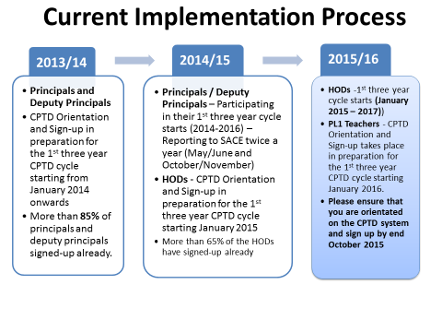

All cohorts must be orientated and sign-up for the CPTD system, a year before their three year cycle starts.

**WHAT IS THE PURPOSE OF THE CPTD SYSTEM SIGN-UP?**

* Create individual CPTD Accounts / Records of educators’/schools’ participation in the CPTD System and professional development uptake
* Provide educators with login details (username and password) through an sms so that they can access the CPTD self-service portal
* Create a clean and updated database of educators and schools with relevant information / fields / variables for teacher education and development purposes (possible link ups with SA SAMS, EMIS, SACE Registration, SAQA qualification validation)

In addition, the sign-up data is being used to develop a report with statistical and narrative information to indicate the state of the teaching profession with regard to the principals, deputy principals and HODs and ultimately inform planning and policy decisions.

**HOW DO I SIGN-UP?**

You can sign-up as follows:

1. **Manually**

* By filling-in the principal/deputy principals/HOD/PL1 profile form obtainable from the SACE website/offices, CPTD system workshop sessions, and provincial education departments’ teacher development units.
* The completed form should be:
  + handed over to the workshop facilitators (if sign-up took place during the workshop session)]
  + faxed to SACE (**086 571 5260**)
  + Posted to SACE (Private Bag x127, CENTURION, 0046)
  + E-mailed to [member@sace.org.za](mailto:member@sace.org.za)

1. **Electronically through the CPTD Self-Service Web Portal as follows:**

**ELECTRONIC SIGN-UP STEPS**

1. Go into [www.sace.org.za](http://www.sace.org.za)
2. Click on the CPTD Tab on top and choose “CPTD Self-service portal”
3. It will take you to the Sign-Up Screen. Then Choose EDUCATOR SIGN-UP”
4. Choose South African Educator or Foreign Educator
5. Enter your details (Name, Surname, SACE Number and ID Number). Remember ID number is a mandatory field.
6. **PLEASE NOTE THAT IF YOU DO NOT ENTER THE SACE REGISTRATION NUMBER, WHEN YOU SIGN-UP, THE SYSTEM WILL SEND YOU A MESSAGE WITH A TEMPORARY USERNAME AND PASSWORD. YOU WILL HAVE 60 DAYS TO REGISTER WITH SACE AS AN EDUCATOR AND UPDATE YOUR CPTD RECORDS WITH THE SACE REGISTRATION NUMBER. IF YOU ARE A SACE REGISTERED EDUCATOR AND FOR SOME REASONS YOU DID NOT ENTER YOUR REGISTRATION NUMBER, WHEN YOU SIGN-UP, YOU WILL STILL RECEIVE SMS WITH TEMPORARY USERNAME AND PASSWORD. PLEASE UPDATE YOUR CPTD RECORDS WITH THE SACE NUMBER AS SOON AS POSSIBLE. ONCE THE SACE REGISTRATION NUMBER UPDATE IS DONE, YOU WILL RECEIVE SMS WITH A NEW USERNAME (YOUR SACE NUMBER) AND PASSWORD (YOUR SURNAME). YOU HAVE AN OPTION OF CHANGING YOUR PASSWORD.**
7. Choose your Position (Principal, Deputy Principal, HOD, PL1 Teacher)
8. SAVE
9. It will take you to a screen with your personal details to complete.
10. Once your done with filling in the information on the screen, SAVE”
11. It will take you back to the LOGIN Screen and give you USERNAME and PASSWORD (Please save them somewhere where they will not get lost. You will also get your username and password through an sms on your cellphone.
12. Then choose EDUCATOR LOGIN on the same screen
13. Enter USERNAME and PASSWORD as they were when you received them
14. Fill in your qualifications, subjects etc
15. You can now navigate through the self-service portal, update information, report a CPTD related problem, etc
16. **PLEASE GIVE US FEEDDBACK ON THE CPTD SELF-SERVICE PORTAL**

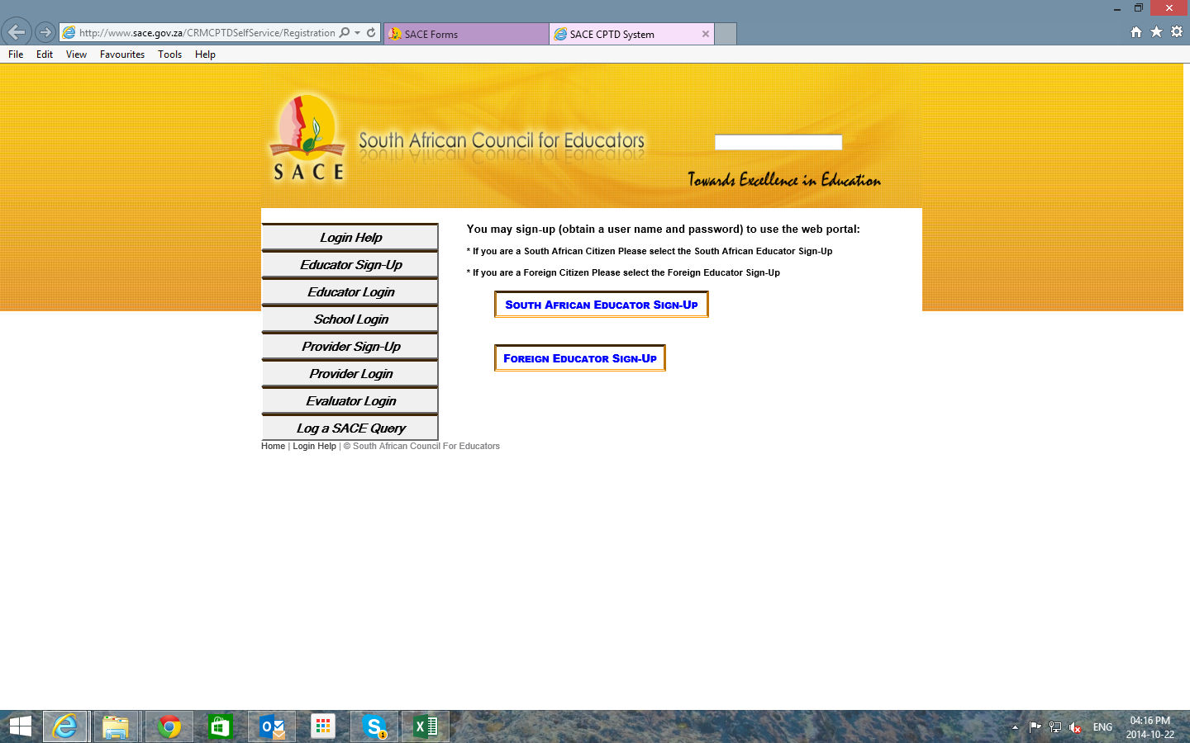

**This Figure Shows the First Screen on the CPTD Self-Service Portal**

**PLEASE NOTE THAT YOU CAN SIGN-UP ELECTRONICALLY THROUGH THE FOLLOWING:**

1. **Any Electronic Gadget** (Desktop Computer, Laptop, IPAD/Tablet, Cell phone and others) to access the SACE website and the CPTD-Self Service Portal - **www.sace.org.za**
2. **SACE Mobisite** - [www.sace.cptd.za](http://www.sace.cptd.za)
3. **CPTD Self-Service Walk-in Centre**

We have also developed the CPTD Self-Service Centre for the number of educators who come to SACE on a daily basis to register for the first time, renew their provisional registration, re-print their lost certificate and others. The centre has 9 work stations / cubicles and connectivity and is being used by the educators to do the following:

* Sign-up and login
* Update qualifications and subjects teaching currently
* Upload/Record PD activities and points earned
* Access database of SACE approved providers and endorsed PD activities
* Developing online Professional Development Portfolio

**WHEN YOU VISIT SACE, YOU ARE WELCOME TO USE THIS CENTRE FOR YOUR ELECTRONIC SIGN-UP, LOGIN INTO THE CPTD SELF SERVICE PORTAL, WORK ON YOUR PROFESSIONAL DEVELOPMENT PORTFOLIO, UPLOAD YOUR PARTICIPATION IN PD ACTIVITIES AND PD POINTS, VIEW YOUR CPTD RECORD AND LOGIN A QUERY.**

1. **CPTD Self –Service Portal Instructional Video/DVD**

We have developed the CPTD Self Service instructional video/DVD. The DVD/Video assist educators to work on the CPTD self-service portal in terms of sign-ups, updating personal and school information, uploading PD points and participation in professional development activities, developing own professional development portfolio online, searching for the approved providers and endorsed PD activities, login a query to SACE. **The DVDs have been distributed to schools through the 9 Provincial Education Departments. The video clips can be accessed through You Tube.**

**Watch the SACE CPTD Self-Service Portal DVD/Video on** <http://www.youtube.com/watch?v=BXxWIgo9VcI>. This link is also available on the SACE Website.

**WHAT IS THE IMPORTANCE OF THE CPTD USERNAME AND PASSWORD I RECEIVE AFTER SIGNING-UP?**

*You have signed-up for the CPTD System and received login details* ***(personal username and password)*** *through sms or the CPTD Self-Service Web Portal Screen. Please keep them safe for future usage***.**

**Go to the Educator Login Tab through the SACE Website and the CPTD Self-Service Portal**

**Use your Username and Password to Log into the CPTD Self-Service Portal and use it for the following:**

* Updating your Personal Details on a **Regular Basis** (address, contact details, qualifications, subjects teaching, and school where you are employed and others)
* Log and Track a Query on the CPTD System Matters
* Access the Database of Endorsed PD Activities / Programmes
* Access the Database of Approved Providers
* Upload/Report PD Activities / Programmes you Participated in (Type 1, Type 2, Type 3 Activities) as soon as possible **(If you report these activities electronically, there is no need to send any manual reporting form to SACE**)
* Upload/Report Earned PD Points **(If you report these points electronically, there is no need to send any manual reporting form to SACE)**
* View Your Annual and Three Years Cycle PD Activities and Points Report
* Work on the PDP online

**HOW DO I REPORT MY PD ACTIVITIES/PROGRAMMES AND POINTS ONLINE?**

* Use your username and password to LOGIN into the CPTD self-service portal
* Go to the **RECORD POINTS** Tab on the top bar
* Click on Type of Activity and Choose the relevant one (***Teacher Initiated, or School Initiated or Externally Initiated)***and **SAVE**
* Go to **ACTIVITY NAME** and choose the relevant PD activity you participated in
* Go to the **DATE** and choose the date you **COMPLETED** an activity **(Remember!** You can only earn PD Points from a completed activity) and **SAVE**
* You will get a message **(on the screen)** that says **“THE ACTIVITY HAS BEEN SUCCESFULLY CAPTURED”**
* You will automatically get a **POINTS ACCOUNT** Screen with **summary of Points Recorded under Teacher, School and Externally Initiated Activities. You will all see** your PD Points status/progress in terms of the **three year cycle**.
* To upload more PD activities / programmes and points, you need to click on the **RECORD POINTS** Tab again.
* To view summary of all PD activities you participated in, go to the **ACTIVITIES COMPLETED** Tab on top.

**PLEASE NOTE***: It is very important to upload/record/report your PD Points according to the PD Points Schedule / Educator’s Guide on How to Participate in My three year cycle.*

**For example, according to the SACE PD Points Schedule you need 8 meetings per annum to earn 10 PD Points under Teacher Initiated Activities***.*

In line with this requirement, you will only earn 10 PD Points after loading/recording / reporting 10 different meetings.

If you upload/record/report 3 meetings in June, for example, your **ACTIVITIES COMPLETED** will show the three meetings you have participated in. Your PD POINTS ACCOUNT will, however, show **0** until you upload / record / report the remaining five (5) meetings in August, for example.

**WHAT HAPPENS IF I LOOSE MY USERNAME AND/OR PASSWORD?**

You should:

* go to **FORGOT MY PASSWORD** on the Educator Login Screen
* Enter the cell number you used when you signed-up OR the last updated cell phone number
* Receive sms with username and password

**Alternatively,** contact SACE’s PD and Research Division (012 663 [9517/ member@sace.org.za](mailto:9517/%20member@sace.org.za) / **086 571 5260)** to re-issue your username and password.

**NB*: Please provide SACE with your Surname, Full names, ID or SACE number to be able to search for your forgotten username and password when you call or send an email/fax.***

**AM I ABLE TO CHANGE MY PASSWORD?**

* YES. Go to the Educator Login Screen
* Choose Change Password and Follow the Prompt

**IF YOU DO NOT HAVE ACCESS TO THE INTERNET, SACE WILL MAKE THE INFORMATION ON THE CPTD SELF-SERVICE PORTAL AVAILABLE TO YOU MANUALLY.**